- Though UK GDP growth underwhelmed in Q3, we think this is more a story of noisy data than cause for renewed concern given the expenditure breakdown suggested that all key parts of the domestic economy performed well. Still, incorporating the new, softer data, may lead us to nudge down our growth forecast when we publish updated projections next week.
- Boosting potential output growth was the theme of the Mansion House speeches. Many of the conclusions of Bank of England Governor Andrew Bailey's speech echoed the findings of our research. But while we agree on the damage that's been done to potential output from Brexit, our modelling suggests the potential impact of even the most extreme Trump tariffs is modest.
After a surprisingly strong first half of 2024, recent softer GDP releases have underwhelmed. September's data continued in that disappointing vein, with GDP falling 0.1% month-on-month. This meant that quarterly growth in Q3 as a whole was just 0.1%, a far cry from the well above-trend pace seen in H1 2024.
But delving into the detail suggests the picture isn't quite as bad as the headline figures suggest. A big part of September's fall in GDP was due to a plunge in information and communications output. This sector has been one of the star performers of recent years, and September's drop is likely to prove a blip. Similarly, the 1% month-on-month fall in manufacturing output just continued the volatile pattern of recent months.
The first cut of the expenditure data for Q3 was also more reassuring. There were solid increases in consumer spending (+0.5% q/q), business investment (+1.2% q/q), and government consumption (+0.6%), with all the apparent weakness concentrated on flows of non-monetary gold (Chart 1).
On balance, we don't think that the Q3 data is cause for renewed concern – it just looks like noisy data after a very strong H1. But the economy is clearly not carrying the sort of momentum that earlier data had suggested. We will publish an updated forecast next week, and incorporating the new data could cause our projections for GDP growth in 2024 and 2025 to slip a little.
Chart 1: All key parts of the domestic economy fared well in Q3 despite slower GDP growth
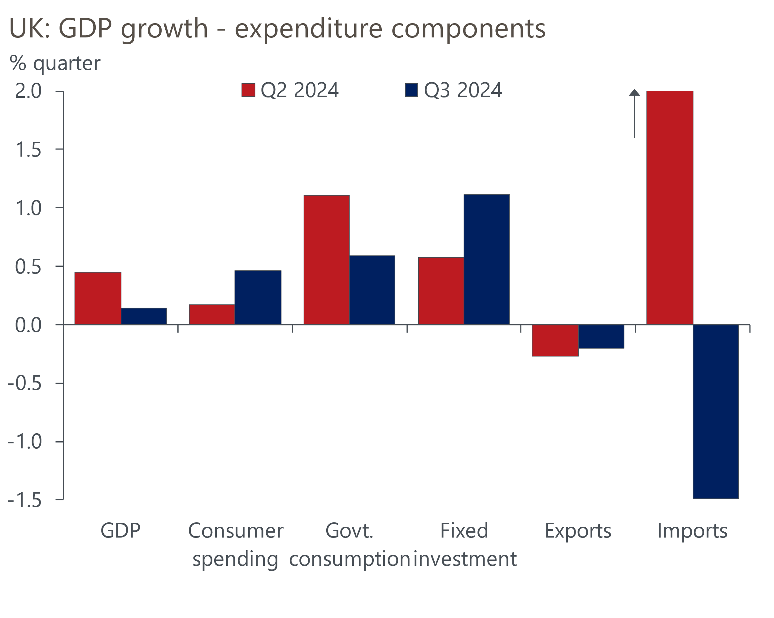
Source: Haver Analytics

The labour market data reported that the slowdown in private sector regular pay growth – the Bank of England's favoured measure – ground to a halt in September (Chart 2). The three-months-on-three-months annualised rate is a better guide to more recent trends and that was both slightly lower and continued to trend downwards. But both measures remain some way above the 3%-3.5% pace that the Monetary Policy Committee thinks is consistent with achieving the inflation target on a sustained basis.
Chart 2: Pay growth remains on a steady downward trend but is still too high for the MPC's liking
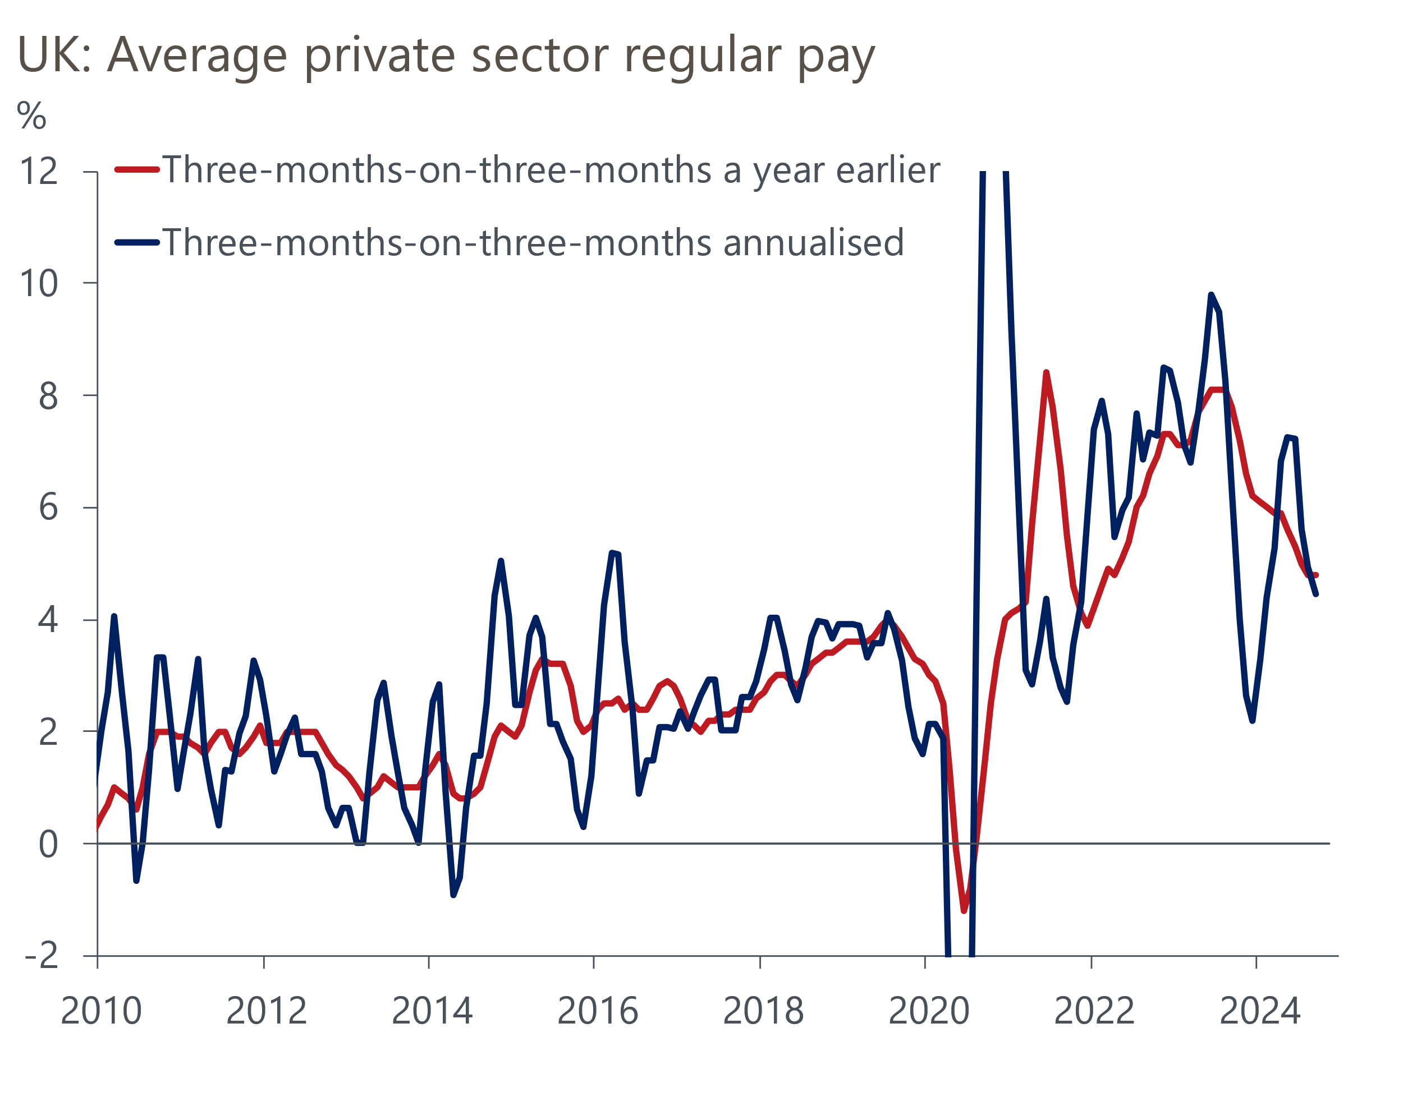
Source: Haver Analytics
But given that the MPC has signalled its focus has moved away from backward-looking data in favour of a more forward-looking approach, we doubt most members will be particularly concerned. Rather, the recent survey finding by BoE agents that firms expect to award pay rises of 2%-4% next year has likely reinforced their conviction that pay growth is broadly on the right track. Evidence of further loosening in labour market conditions will add to the downward pressures on pay – vacancies continued to nudge down and HMRC's count of payrolled employees shrank for a third successive month in October.
Bank of England Governor Andrew Bailey opted not to talk about monetary policy in his Mansion House speech on Thursday evening. Rather, he focused on the UK's poor potential output growth since the global financial crisis, framing his remarks around five key questions. In many respects, his diagnosis of the problems and assessment of the potential solutions were like our own.
Bailey welcomed the increase in government investment announced in the Budget, but argued this paled in importance compared with boosting business investment. In this respect, he welcomed the plan announced by the Chancellor at the Mansion House dinner to reform the financial system. But the Governor brushed over the consequences for investment from the damage to profitability caused by the upcoming rise in employers' national insurance contributions. Meanwhile, on AI, he echoed our cautious optimism that it will likely offer a decent boost to potential output growth, but that those gains will take time to emerge.
On labour supply, he recognised the importance of ageing and hinted at support for raising the state pension age, one of our ideas for boosting potential growth. As part of a section on data measurement, Bailey expressed his frustration that the ONS's failure to resolve problems with the Labour Force Survey – which based on this week's data seem to be deepening – hinders analysis of the UK's participation problem.
Arguably Bailey's most interesting intervention was on trade policy. He was much more forthright on the damaging impact of Brexit than he had been when the previous government was in office, emphasising the need to rebuild relations with the EU. This was another recommendation we made in our growth plan, and his call was echoed by the Chancellor. Both also alluded to concerns about the impact of President-elect Trump's trade policies. On this subject, our modelling suggests the worries might be overstated. In a note published this week, we argued that the UK would be well down the list of US priorities when it came to increasing tariffs. But even if large, across-the-board tariff increases are imposed and there is full retaliation from the UK and others, the macroeconomic impact on the UK would be limited.

The week ahead
CPI inflation dropped to a three-and-a-half year low of 1.7% in September, but we think there was a strong rebound in October for two reasons. First, September's outturn was dampened by strong base effects, but these will now fade. And second, the energy price cap increased by 9.5% on October 1. The impact of these factors will be mitigated by a bigger drag from the petrol category, with weekly data from the Department of Energy & Climate Change suggesting that pump prices fell by 2% between September and October, after a 2% rise between those months last year. But we still expect a chunky rise in CPI inflation to 2.2% in October.
Retail sales rose in three successive months to September, but we think there's likely to have been a correction in October. In particular, in August and September, sales in non-food stores spiked well above the levels seen earlier in the year. We expect total retail sales to have fallen by 0.8% m/m in October.
The PMIs have plunged in the past two months, but this seemed to be related to sentiment as much as an actual slowdown in economic activity. The survey period for November's flash S&P Global survey is likely to have fallen after the US election, so the degree of political uncertainty should have subsided. But equally, the Budget and its big rise in tax on business will be fresh in the minds of respondents. A wide range of outcomes is possible, but we expect the PMIs to stabilise close to October's balances.
Table 1: Week ahead calendar
Date | Events | Period | Measure | Unit | Previous | Forecast
Nov 20 | CPI inflation | Oct | m/m | % | 0.0 | 0.5
Nov 20 | CPI inflation | Oct | y/y | % | 1.7 | 2.2
Nov 20 | RPI inflation | Oct | m/m | % | -0.3 | 0.7
Nov 20 | RPI inflation | Oct | y/y | % | 2.7 | 3.6
Nov 20 | Producer input prices | Oct | m/m | % | -1.0 | -0.2
Nov 20 | Producer input prices | Oct | y/y | % | -2.3 | -3.0
Nov 20 | Producer output prices | Oct | m/m | % | -0.5 | -0.1
Nov 20 | Producer output prices | Oct | y/y | % | -0.7 | -1.1
Nov 20 | Land Registry house prices | Sep | y/y | % | 2.8 | 3.0
Nov 21 | Public finances | Oct | PSNB ex | £bn | 16.6 | 10.5
Nov 22 | GfK consumer confidence | Nov | Headline | % bal | -21 | -20
Nov 22 | Retail sales inc fuel | Oct | m/m | % | 0.3 | -0.8
Nov 22 | Retail sales inc fuel | Oct | y/y | % | 3.9 | 2.9
Nov 22 | S&P Global manufacturing | Nov | PMI | % bal | 49.9 | 50.0
Nov 22 | S&P Global services | Nov | PMI | % bal | 52.0 | 52.0
Nov 22 | S&P Global composite | Nov | PMI | % bal | 51.8 | 51.8
Source: Oxford Economics

Key forecasts
Table 2: UK forecast overview
(Annual percentage changes unless specified)
 | 2022 | 2023 | 2024 | 2025 | 2026 | 2027
GDP | 4.8 | 0.3 | 1.0 | 1.5 | 1.7 | 1.8
Private consumption | 7.3 | 0.5 | 0.8 | 1.7 | 1.5 | 1.6
Fixed investment | 5.1 | -0.1 | 0.6 | 1.2 | 3.4 | 2.5
Government consumption | 0.6 | 0.6 | 2.4 | 2.9 | 1.6 | 1.6
Exports of goods and services | 12.6 | -2.2 | -0.8 | 3.0 | 2.0 | 1.8
Imports of goods and services | 13.0 | -3.4 | 2.8 | 3.2 | 2.6 | 1.8
Industrial Production | -6.4 | -1.2 | -0.8 | 1.0 | 1.2 | 1.0
Consumer prices | 9.1 | 7.3 | 2.5 | 2.5 | 2.5 | 2.2
Unemployment rate (%) | 3.9 | 4.0 | 4.3 | 4.4 | 4.3 | 4.2
Current a/c balance (% of GDP) | -2.2 | -2.0 | -2.9 | -2.7 | -2.9 | -2.8
Government balance (% of GDP) | 4.1 | 4.9 | 4.4 | 3.5 | 2.8 | 2.2
Cen. bank policy rate (%, EOP) | 3.50 | 5.25 | 4.75 | 3.75 | 2.75 | 2.00
10yr govt. bond yield (%, EOP) | 3.67 | 3.54 | 4.50 | 4.05 | 3.34 | 2.85
Exchange rate (US$ per £, EOP) | 1.20 | 1.27 | 1.27 | 1.29 | 1.30 | 1.33
Exchange rate (euro per £, EOP) | 1.13 | 1.15 | 1.21 | 1.20 | 1.19 | 1.19
Source: Oxford Economics
Table 3: Quarterly forecasts for the UK
 | 2024 |  |  |  | 2025
 | Q1 | Q2 | Q3 | Q4 | Q1 | Q2 | Q3 | Q4
GDP (% year) | 0.3 | 0.7 | 1.1 | 1.9 | 1.6 | 1.5 | 1.6 | 1.5
CPI inflation (% year) | 3.5 | 2.1 | 2.1 | 2.4 | 2.5 | 2.3 | 2.7 | 2.6
Bank Rate (%, EOP) | 5.25 | 5.25 | 5.00 | 4.75 | 4.50 | 4.25 | 4.00 | 3.75
10yr gilt yield (%, EOP) | 3.95 | 4.17 | 4.00 | 4.50 | 4.42 | 4.31 | 4.19 | 4.05
US$ per £ (EOP) | 1.26 | 1.26 | 1.34 | 1.27 | 1.27 | 1.28 | 1.28 | 1.29
Euro per £ (EOP) | 1.17 | 1.18 | 1.20 | 1.21 | 1.21 | 1.21 | 1.21 | 1.20
Source: Oxford Economics

Latest Country Economic Forecast:
October 15, 2024

Recent publications

Data Insights
GDP growth underwhelmed in Q3
Labour market data to keep rate cuts gradual
Composite PMI consistent with trend growth in late-2024
Manufacturing PMI slipped below 50 in October
Cheaper deals supported a further rise in mortgage approvals

Research Briefings
Macro impact of Trump’s tariffs shouldn’t be overstated
MPC sticks to the cut-hold tempo
Markets have soured on the Budget, but calm should return
MPC preview – November cut looks virtually certain
New fiscal rules create room for looser policy

Contacts

Oxford Economics' UK team
- Andrew Goodwin - Chief UK Economist - agoodwin@oxfordeconomics.com
- Edward Allenby - UK Economist - eallenby@oxfordeconomics.com

